Lab 8 – Janice Gepner

1. Link to Github with apps from videos: <https://github.com/jgepner/Topic-8>

hello_vue.html

vue_forms.html

vue_shopping_cart.html

tast_list.html

2. The Vue warning message means that a property was created but hasn’t been used yet. It can be ignored safely. You see it if you check DevTools while an app is in progress: after property created, but not yet used in data. You fix it by using the property in the data section.

3. Screenshot:

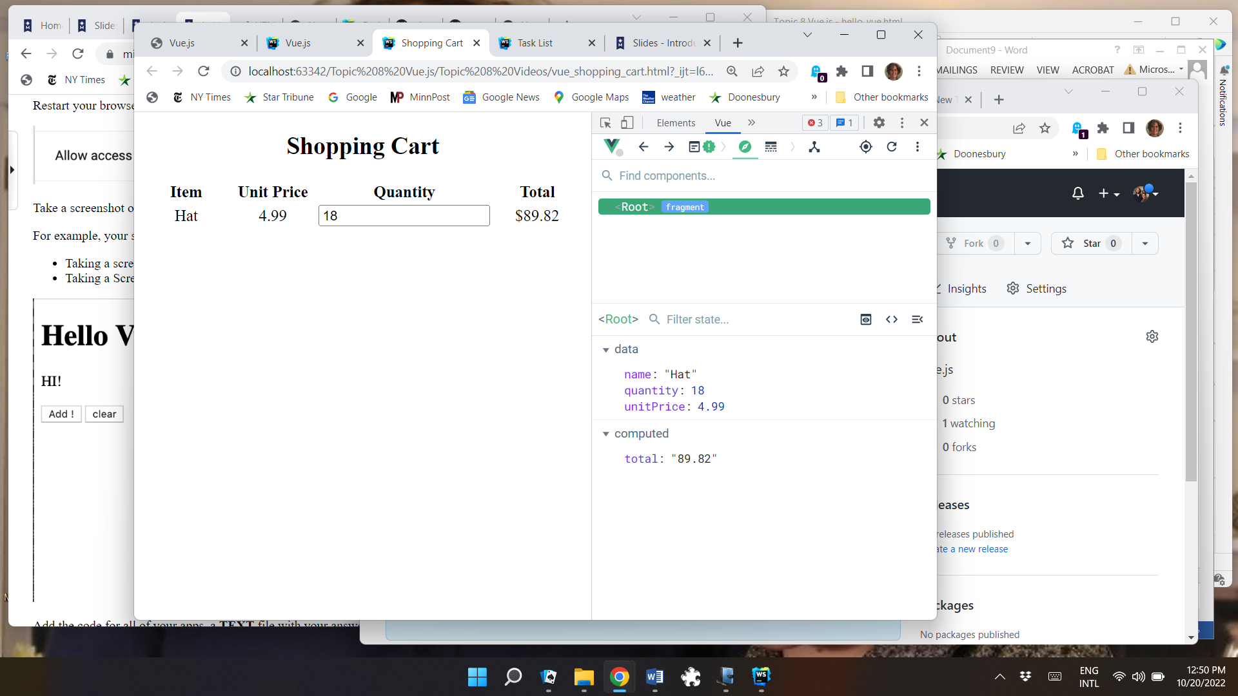

4. Link to GitHub pages: <https://jgepner.github.io/Topic-8/>